**Practical No : 0 (Basic of rpc)**

**Roll No : B -09 Date: 21/8/20**

Program 1: Implement concept of RPC (Basic)

Client :

import socket #client code

HOST = '127.0.0.10'

PORT = 65432

with socket.socket(socket.AF_INET, socket.SOCK_STREAM) as s: s.connect((HOST, PORT))

print("CONNECTED")

n=0 while(n!=1):

datai=str(input("**STOP=STOP** ENTER MESSAGE: ")) if datai!="STOP":

s.sendall(b'HI') data = s.recv(1024)

if datai=="STOP": n=1

print('Received', repr(data))

Server:

import socket

HOST = '127.0.0.10'

PORT = 65432

with socket.socket(socket.AF_INET, socket.SOCK_STREAM) as s: s.bind((HOST, PORT))

s.listen()

conn, addr = s.accept() with conn:

print('Connected by', addr) while True:

data = conn.recv(1024);print(data) if not data:

break conn.sendall(data)

**OUTPUT:**

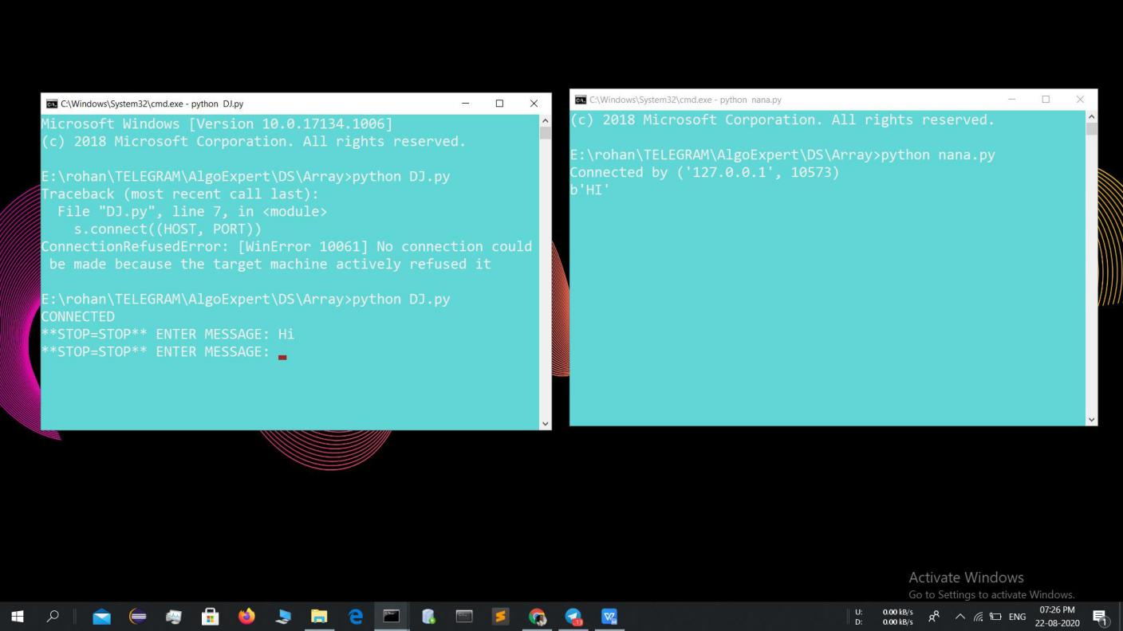

**Practical No : 1**

**Roll No : B -09 Date: 21/8/20**

Program 1: Implement concept of RPC

Client :

import xmlrpc.client

with xmlrpc.client.ServerProxy("http://localhost:8000/") as proxy: print("For 77 is %s" %str(proxy.countCoin(77)))

print("For 20 is %s" %str(proxy.countCoin(20)))

Server:

from xmlrpc.server import SimpleXMLRPCServer import math as m

def sr(i): return 2**i

def countCoin(n): for _ in range(1):

p=0

for i in range(0,n): #print(sr(i),i)

if n>=sr(i): p+=1

else:

break return(p)

server = SimpleXMLRPCServer(("localhost",8000)) print("server listening on 8000") server.register_function(countCoin,"countCoin") server.serve_forever()

**OUTPUT:**

